**Bruce Onobrakpeya (1932- )**

Printmaker, sculptor, painter and inventor of new techniques, Bruce Onobrakpeya was one of the major figures to emerge from the Zaria Arts Society in Nigeria in the 1950s.

An innovator and experimentalist in printmaking, Onobrakpeya developed many techniques including ‘bronze lino relief’, ‘hydrochloric acid accident’, and in 1967, a deep etching technique called ‘plastograph’ that uses plates cast in plaster. In a continuous process of innovation, Bruce started making prints from these ‘plastercasts’, then coated the original plates with bronze in order to make the casts into pieces of art work themselves. In later years, Onobrakpeya recast these original plates into columns of resin to create sculptural installation-shrines, thereby not only reinventing the idea of printing itself, but reinterpreting African shrine traditions to give these ritual places new meanings. Together with his generation of modern artists rooted in the historical moment of African independence, Onobrakpeya helped to critically question Eurocentric assumptions by re-writing their own history.

Bruce Onobrakpeya turned to printmaking as his main medium driven by a desire to create art that was relatively affordable to buy in order to encourage local patronage during the years following Nigerian independence in 1960. This allowed a thriving Nigerian art market to flourish independently from the European dominated art market of other African nations during the transition from colonialism to independence. In the Nigerian context, state patronage, local businesses, the church and private collectors emerged mostly from the growing class of elites who benefitted from the oil economy boom of the 1970s. Onobrakpeya was instrumental in encouraging this local art market and local patronage to flourish. As dele jegede writes, “his prints are in the collections of people of diverse social standings: from the Duke of Edinburgh to Chinua Achebe; from the Papal Villa in Rome to the middle-class worker in Lagos”.

Born into a Christian family who were originally from Agbarha-Otor in Delta State, the Urhobo-speaking area to the south of Benin City, Onobrakpeya moved to Benin City as a child and went to Western Boys High School where he later worked as an art teacher from 1953 to 1956. He then taught for another year at Ondo Boys High School before starting his art training at the Nigerian College of Arts, Science and Technology (now the Ahmadu Bello University, Zaria) in 1957, funded by a Federal Government Scholarship. Here, Onobrakpeya was trained in technical Western art techniques and styles and quickly became an active member of the Zaria Arts Society which formed in 1958 by a group of artists led by Uche Okeke (1933-). The Zaria Rebels were against colonial-based British art training and advocated instead for the indigenisation of the visual arts through the idea of ‘Natural Synthesis’. Bruce Onobrapkeya embraced these ideals using Nigerian folklore, myths and legends in his work, and in later years, through the invention of a scripture called ‘Ibiebe’ which translated into English means alphabets of sign characters in Urhobo, an oral-based language which had never been written. Bruce speaks of his creative process: “I originally composed them as imaginary calligraphic motifs, but I have now ascribed meanings to them.”

During the 1960s, and early 1970s, Onobrakpeya attended formative art workshops organized by Ulli Beier (1922-2001) at Ibadan, Oshogbo and Ife-Ife. His first solo exhibition took place in 1959 in Ughelli, Niger Delta, and since then he has exhibited extensively at home and throughout the world at the Tate Modern in London, the National Museum of African Art at the Smithsonian in Washington D.C., the National Gallery of Modern Art in Lagos, and the Venice Biennale, where in 1990 he was chosen to represent Nigeria. Bruce Onobrakpeya also had a long and successful teaching career at St. Gregory College in Lagos (1963-1979). In 1989, the Bruce Onobrakpeya Foundation was established and the Ovumaroro Gallery and Studio, Ovumaroro meaning ‘self-examination leading to self-knowledge and self-development’.

Bruce Onobrakpeya’s work distinctly makes use of past traditions from a variety of cultural sources from Nigeria’s diverse population, with a common theme running throughout which Dr Babatunde Lawal comments on in *Symbols of Ancestral Groves*: “The strong Edo, Yoruba and Hausa/Fulani cultural elements are traceable partly to his experiences in Benin-city, Ondo, Zaria and Lagos, and partly from his relentless search for a national identity out of the multi-ethnic images of Nigeria’s past.”

Within his search for what Onobrakpeya calls ‘unity in diversity’, he has produced a series of important work which include: Urhobo history, myths, legends and folktales; ‘Symbols of Ancestral Groves’ (1978-1984) depicting the Benin kingdom royal ceremonies and regalia; traditional Christian themes; the Sahelian Masquerades (1985-1988) addressing the desertification of the Sahelian regions of Africa; Social Unrest (1995-1999) on military dictatorship and political instability; and finally, the Installation Period (1995 to date) where Onobrakpeya reassembles recycled materials to draw attention to the environmental impact of waste.

Referred to as ‘Nigeria’s master printmaker’ Bruce Onobrakpeya is one of the most acclaimed contemporary artists to have emerged from the generation of post-independent Nigeria. His technical innovations and reinvention of the humble print has meant that his art itself has formed a tradition and a history of its own, blurring the Eurocentric imposed categories of ‘high’ and ‘popular’, ‘modern’ and ‘traditional’ art. A keen observer and visual orator of Nigeria’s environmental, cultural, and political present and past, Bruce Onobrakpeya continues to inspire and encourage future artists, as he himself says: “As we enter a new century, it is our fervent prayer that the combined efforts of these generations, old and new, will enable us to move forward into the challenges of the new future.”

References and Further Reading

Literature:

Lunn, F. and Havell, J. (1995), *Seven Stories: about modern art in Africa*, Paris: Flammarion.

Picton, J. (1997), *Image and Form: Prints, Drawings and Sculpture from South African and Nigeria*, London: Brunei Gallery, School of Oriental and African Studies.

Quel, S. [ed.] (1985), *Symbols of Ancestral Groves: monograph of prints and paintings,  
 1978-1985*, *Bruce Onobrakpeya,* [intro. by Babatunde Lawal]. Lagos: Ovuomaroro Gallery.

Electronic Sources:

jegede, d. (1985), on *Bruce Onobrakpeya*, Nigeria Magazine, Vol. 53 (3), pp. 17-23.

Lawal, B. (1976), on *Bruce Onobrakpeya,* Nigeria Magazine, n. 120, pp50-59.

**IMAGE**

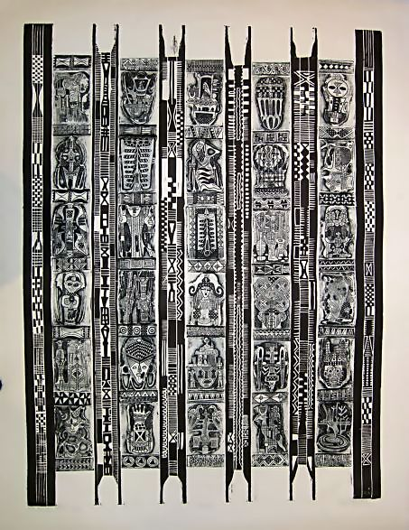

Artist: Bruce Onobrakpeya   
Medium: Plastograph E5/7  
Theme: Esirogbo (Bridal Panel) I  
Year of production: 2004  
Size: 107 x 79 cm  
Catalogue number: BO1  
Status: Sold

http://www.modernafricanart.com/wp-content/gallery/bruce-gallery/bo1.jpg